POKUPSKI DRMEŠ
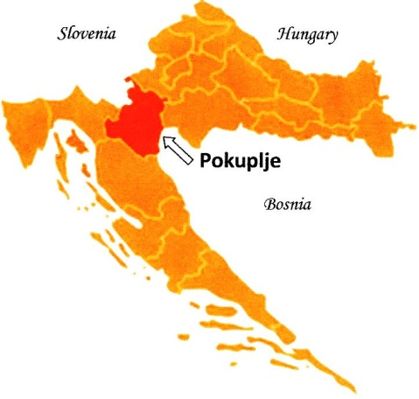
Croatia

The region of Pokuplje is a picturesque territory in central Croatia situated near Kupa River. This dance was originally done during wedding celebrations in a closed reel formation. Sometimes is called Pokupski Svatovski Drmeš (Pokuplje Wedding Shaking Dance).That dance is often accompanied by the song called “samica” (solo singing) where is used totally different singing melody during the dance.
Željko researched this region during many weddings and festivals from 1976-1986.

TRANSLATION: Pokuplje Shaking Dance

PRONUNCIATION: PAW-koop-skee DER-mesh

MUSIC: CD „ Željko Jergan’s Dance Journey”, Band 5

FORMATION: Closed reel of mixed dancers, with sometimes one couple in the center. An alternative formation is a circle inside a circle. Hands are joined in “back hold”, with M arms lower and W higher, or “back basket hold” L over R.
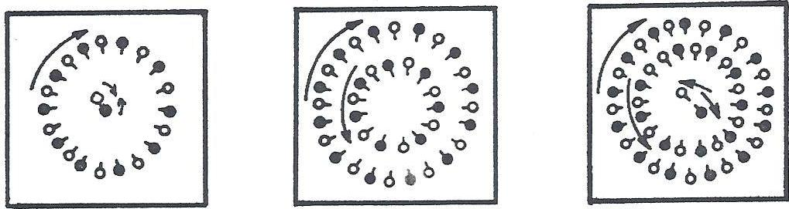

STEPS: Drmeš on R foot: Step R in place, pushing L foot fwd (ct 1), bounce on R with L heel touching floor, weight on both feet (ct 2), step R slightly to R (ct &). This will also be done on L foot.
Double Drmeš: Step R in place, pushing L foot fwd (ct 1), bounce on R with L heel touching floor, weight on both feet (ct 2), with L foot beside R, bounce with wt on both feet (ct &). Repeat on with opp ftwk.

STYLE: Smooth gliding movements (Šetnja) with varying amplitudes of Drmeš steps.
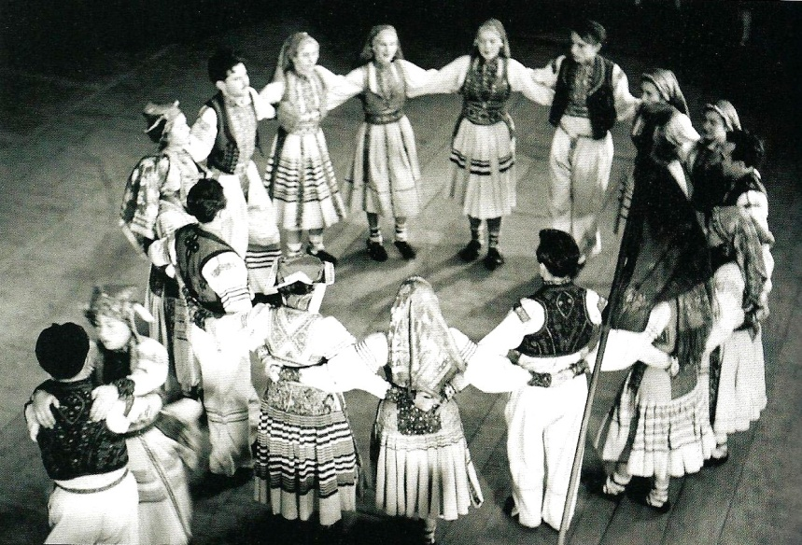

Pokupski drmeš Pg 2
-----------------------------------------------------------------------------------------------------------------------------------------
METER: 2/4 PATTERN
-----------------------------------------------------------------------------------------------------------------------------------------

Meas. Part A – INTRODUCTION & TRAVEL (ŠETNJA):

1-4 No action
5 Sway left (ct 1, 2)
6 Sway right (ct 1, 2)
7 Sway left (ct 1, 2)
8 Sway R in pl (ct 1), sway L in place (ct 2)
9 In RLOD: step R on heel (ct 1), step L on ball of the foot (ct 2)
(This is done smoothly so head stay level, no up and down movement of body).
10-15 Repeat meas 9 (6 times)
16 Step R on heel (ct 1), hop L (ct 2)
(Cue meas 9-16; 15 gliding steps and 1 hop)

FIG II: DRMEŠ
1 Facing ctr and moving L (CW) – Drmeš on R foot
2-8 Repeat meas 1 drmeš seven more times (8 total), ending with wt on both feet
9 Facing ctr and moving R (CCW) – Drmeš on L foot
10-16 Repeat meas 9 drmeš seven more times (8 total), ending with wt on both feet

FIG I: TRAVEL
1-8 In ROLD: repeat meas 9-16 of intro/travel with opposite footwork (15 gliding steps and 1 hop starting with R, CW)
9-16 In LOD: repeat meas 9-16 of intro/travel (15 gliding steps and 1 hop starting with L, CCW)

FIG III: IN & OUT
1 Step R twd ctr (ct 1), hop R (ct 2)
2 Step L twd ctr (ct 1), chug bkwd on L (ct 2)
3 4 small running steps backing out from ctr; RLRL (cts 1, &, 2, &)
4 Small leap onto R in pl (ct 1), small leap onto L in pl (ct 2)
5-16 Repeat meas 1-4 three more times (4 total)

FIG IV: DOUBLE DRMEŠ & STEP, HOP, STEP
Facing ctr – in place
1-2 Double Drmeš, first on R foot then on L foot
3-8 Repeat meas 1 & 2 three more times (4 total)
9-16 Step-hop-step In ROLD; Step R (ct 1), hop on R (ct 2), step L (ct &) – leaning slightly forward from waist and facing L while moving, hold R foot near L ankle.

Dance Sequence: Figures: A, II, I, III, I, IV

Repeat dance from beg one more time! Replace Intro – travel, Part A, with Fig. I

Dance notes by Željko Jergan & Cricket Raybern, May 2010

Pokupski drmeš Pg 3
POKUPSKI (Svatovski) DRMEŠ
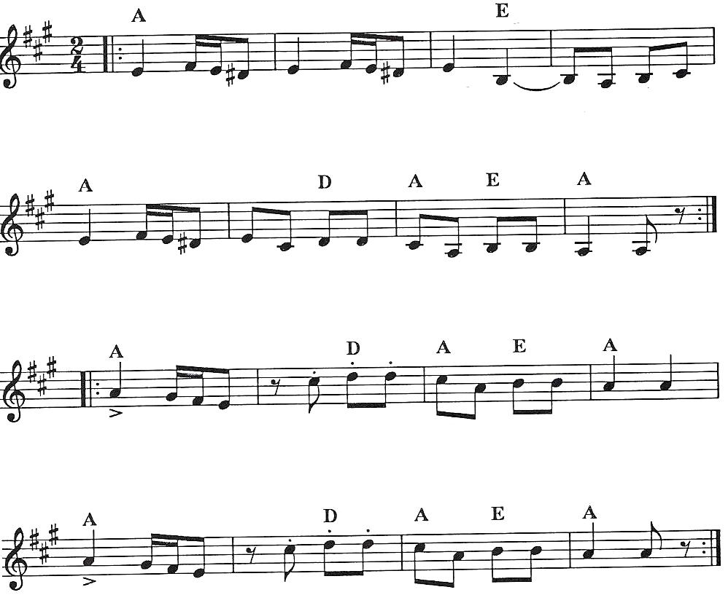

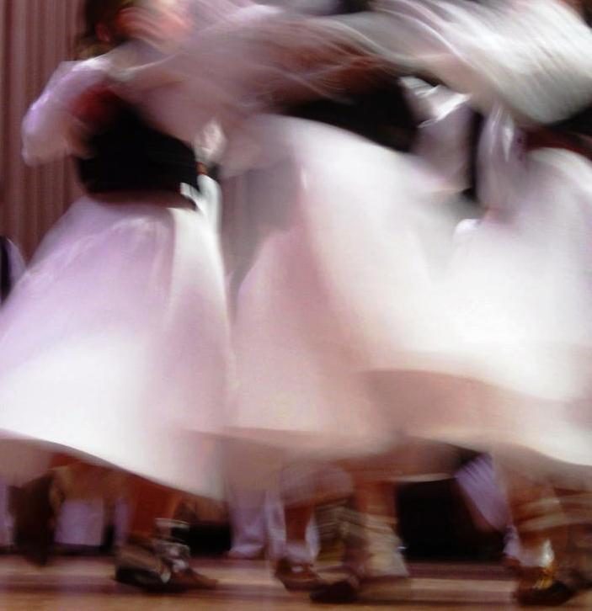

Presented by Željko Jergan Dance notes by Željko Jergan & Cricket Raybern, May 2011

